**Week 4 – LAB 3**

1. **First question:**

Write a Java program to get a number from the user and print whether it is positive or negative and if it is odd or even.

**Solution:**

import java.util.Scanner;

public class Ex1 {

public static void main(String[] args) {

Scanner in = new Scanner (System.in);

System.out.println("Please Enter a Number");

int n = in.nextInt();

if (n>0)

System.out.println("This is a positive number");

else

System.out.println("this a negative number");

if(n%2 ==1)

System.out.println("This is an Odd number");

else

System.out.println("this is an even number");

}

}

1. **Second question**

Take three numbers from the user and print the greatest number and the smaller number.

**Solution:**

import java.util.Scanner;

public class Ex2 {

public static void main(String[] args)

{

Scanner input = new Scanner(System.in);

System.out.print("Kindely enter three numbers (click enter after each number):");

int num1 = input.nextInt();

int num2 = input. nextInt ();

int num3 = input. nextInt ();

if (num1 >= num3 && num1 >= num2)

System.out.println("The greatest number is = " + num1);

else if (num2 >= num1 && num2 >= num3)

System.out.println("The greatest number is = " + num2);

else

System.out.println("The greatest number is = " + num3);

if (num1 <= num3 && num1 <= num2)

System.out.println("The smallest number is = " + num1);

else if (num2 <= num1 && num2 <= num3)

System.out.println("The smallest number is = " + num2);

else

System.out.println("The smallest number is = " + num3);

}

}

1. **Third question:**

Write a Java program that reads a floating-point number and prints "zero" if the number is zero. Otherwise, print "positive" or "negative". Add "small" if the absolute value of the number is less than 1, or "large" if it exceeds 1,000,000.

**Solution:**

import java.util.Scanner;

public class Exercise4 {

public static void main(String[] args)

{

Scanner in = new Scanner(System.in);

System.out.print("Input value: ");

double input = in.nextDouble();

if (input > 0)

{

if (input < 1)

{

System.out.println("Positive small number");

}

else if (input > 1000000)

{

System.out.println("Positive large number");

}

else

{

System.out.println("Positive number");

}

}

else if (input < 0)

{

if (Math.abs(input) < 1)

{

System.out.println("Negative small number");

}

else if (Math.abs(input) > 1000000)

{

System.out.println("Negative large number");

}

else

{

System.out.println("Negative number");

}

}

else

{

System.out.println("Zero");

}

}

}

1. **Forth question:**

Write a Java program to solve quadratic equation: **ax2 + bx + c =0**. Where a, b and c are real numbers and a != 0

The term **b2-4ac**is known as the discriminant of a quadratic equation. It tells the nature of the roots.

1. If the discriminant is greater than 0, the roots are real and different.

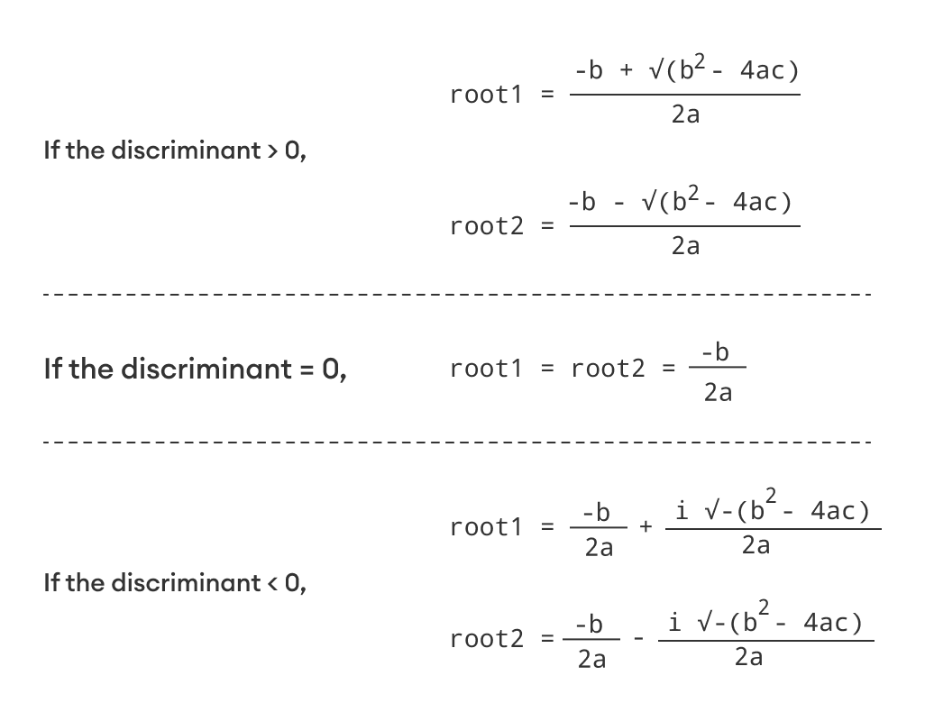

1. If the discriminant is equal to 0, the roots are real and equal.



1. If the discriminant is less than 0, the equation has no real root.

**Solution:**

import java.util.Scanner;

public class Ex5 {

public static void main(String[] Strings) {

Scanner input = new Scanner(System.in);

System.out.print("Input a: ");

double a = input.nextDouble();

System.out.print("Input b: ");

double b = input.nextDouble();

System.out.print("Input c: ");

double c = input.nextDouble();

double result = b * b - 4.0 * a * c;

if (result > 0.0) {

double r1 = (-b + Math.pow(result, 0.5)) / (2.0 * a);

double r2 = (-b - Math.pow(result, 0.5)) / (2.0 * a);

System.out.println("The roots are " + r1 + " and " + r2);

} else if (result == 0.0) {

double r1 = -b / (2.0 * a);

System.out.println("The root is " + r1);

} else {

System.out.println("The equation has no real roots.");

}

}

}

1. **Fifth question:**

Write a Java program that reads two floating-point numbers and tests whether they are the same up to three decimal places.

**Solution:**

//This Mohammed Saffar Code

import java.util.Scanner;

public class Ex3

{

public static void main(String[] args)

{

Scanner input = new Scanner(System.in);

System.out.print("Kindely enter two numbers (click enter after each number):");

double num1 = input.nextDouble();

double num2 = input.nextDouble();

final double PL=1E-3;//=0.001

if (Math.abs(num1 - num2) <= PL)

System.out.println("Entered numbers are the same up to third decimal place.");

else

{

if((num1 - num2)>0)

System.out.println("Greatest Number = " + num1);

else

System.out.println("Greatest Number = " + num2);

}

}

}